# *Lab 4 – Azure Project analysis*

Date Assigned: Tuesday, Sept 3

Date due: **Tuesday, Sept 3, 5pm**

**Learning Objectives**

Upon successful completion of this lab exercise, the student will be able to:

* Analyze existing projects to determine how they are structured
* Create a good user story (review);
* Detail a user story by fleshing out additional information needed for implementation;
* Decompose a user story into tasks;
* Create an initial estimate for tasks;
* Determine the tasks that will fit in a sprint; and
* Use Azure DevOps to track and manage user stories, tasks, estimates, product backlog, and sprint backlog.

## **Part A – Analyze existing Projects**

You have access to existing projects. Take a look and understand how they are organized and how to navigate the Azure DevOps tool.

1. Go to: https://csazure.cegep-heritage.qc.ca:8080/F2023-DevProject
2. There are 4 projects for you to analyze from last year:

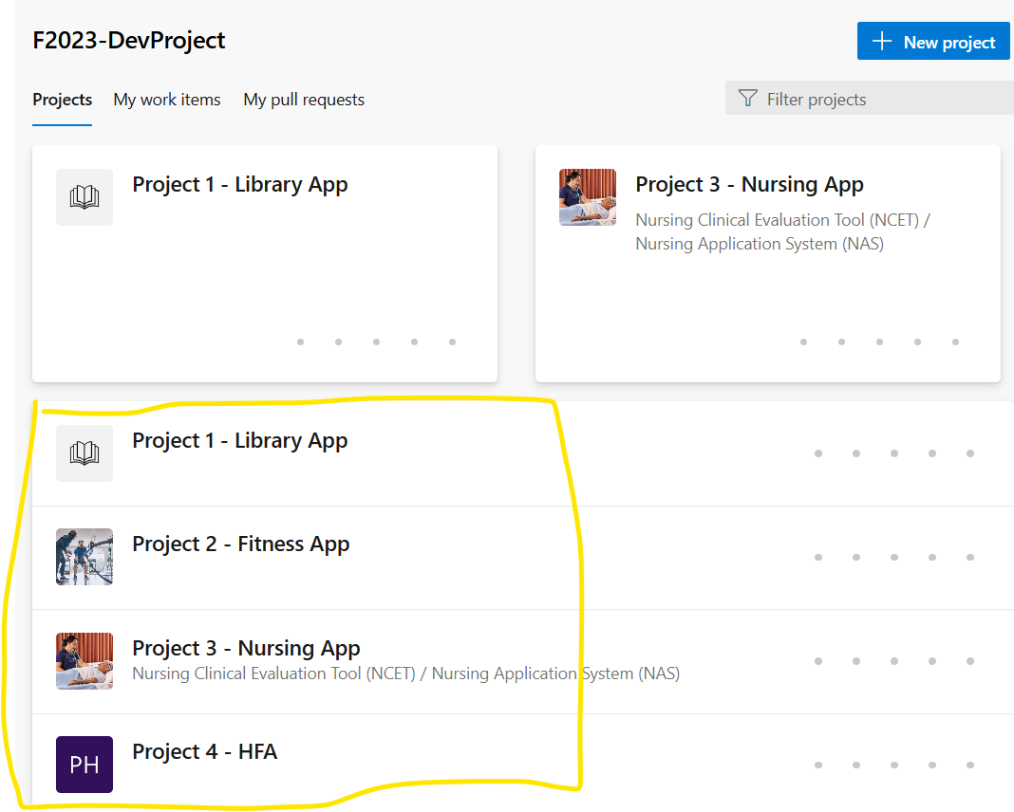

1. Answer the following and provide screen shots
   1. Find the main overview for each project and provide screen shots. (4 marks)

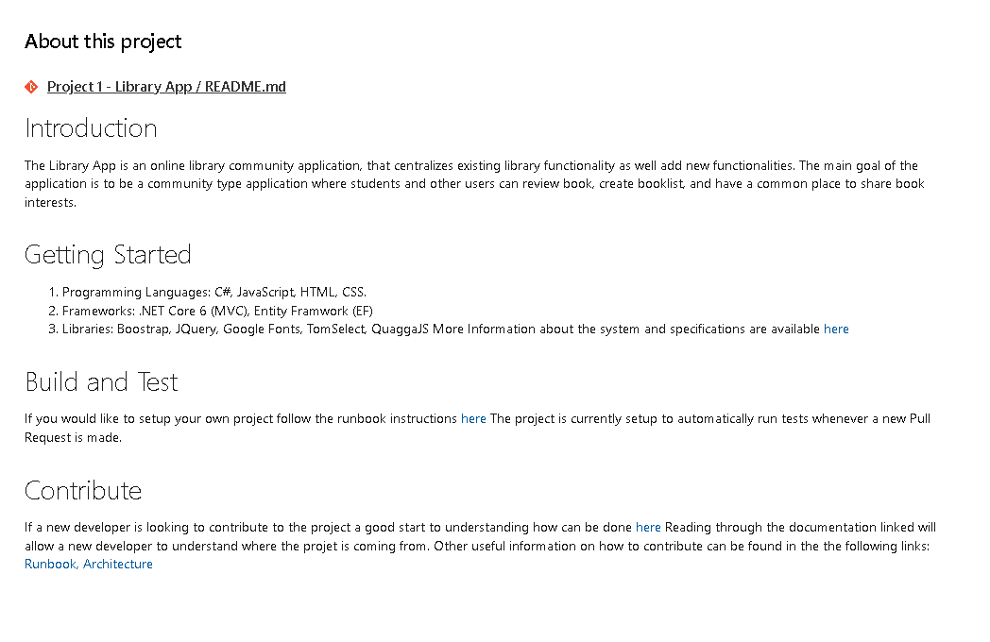 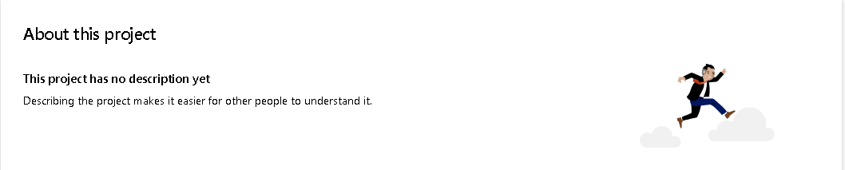 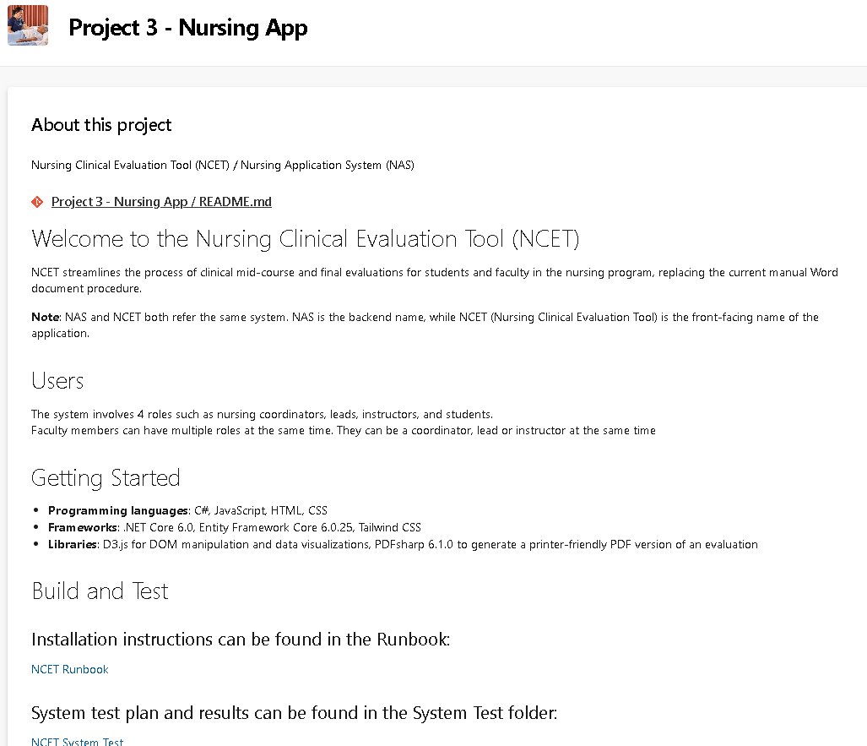 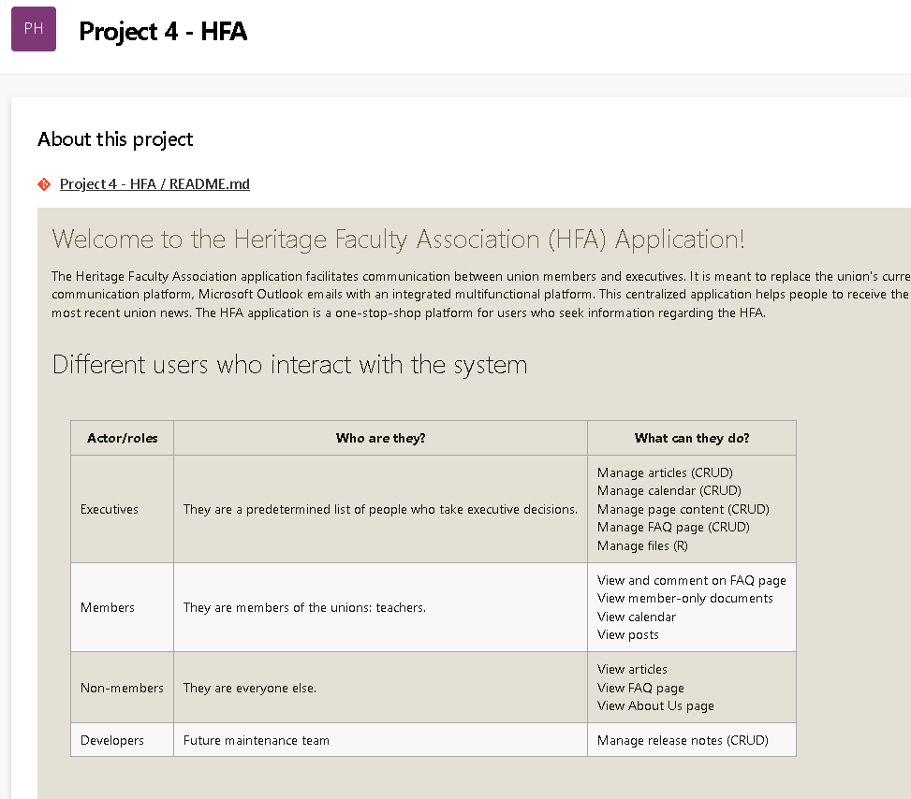

* 1. Find a product backlog (2 marks)

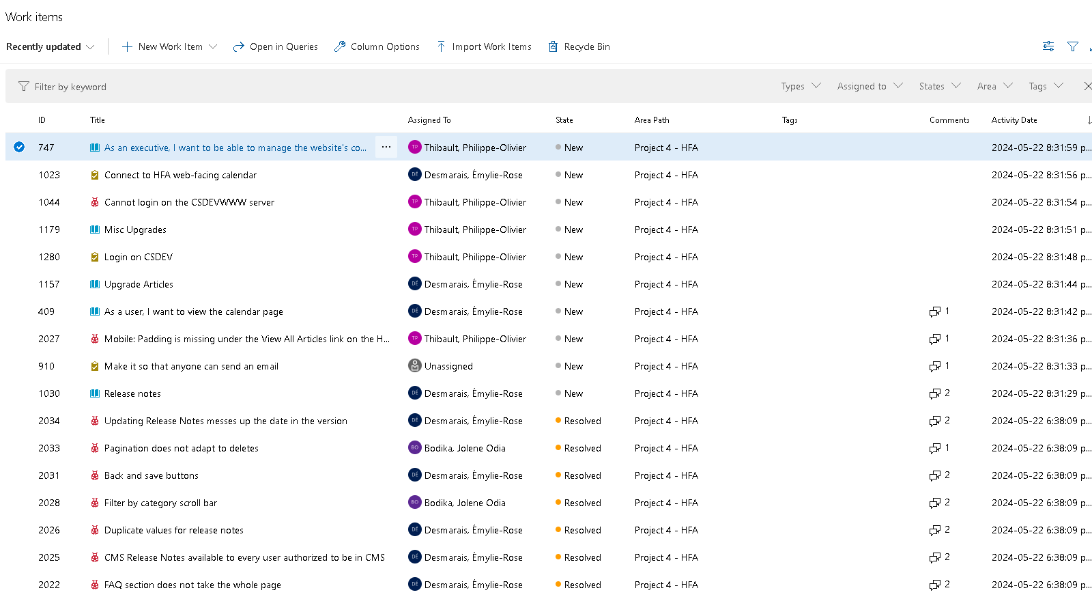

* 1. Find a sprint backlog and what was committed (2 marks)

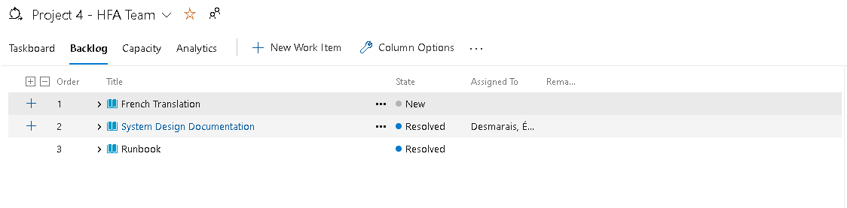

* 1. Find a taskboard (aka KanBan board) for a sprint (2 marks)

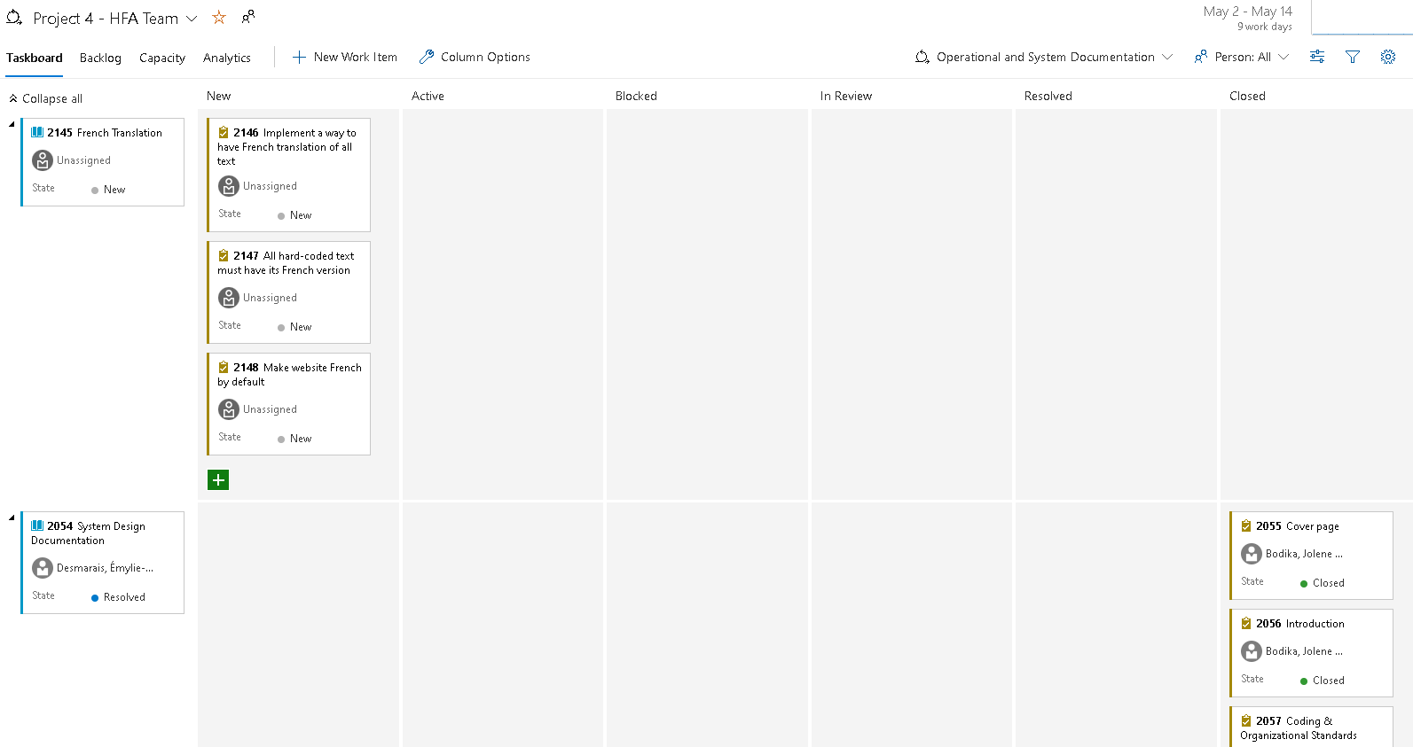

* 1. Find a Burndown chart for a sprint. What’s your analysis on how well things were tasked out and how well the work was paced out? (4 marks)

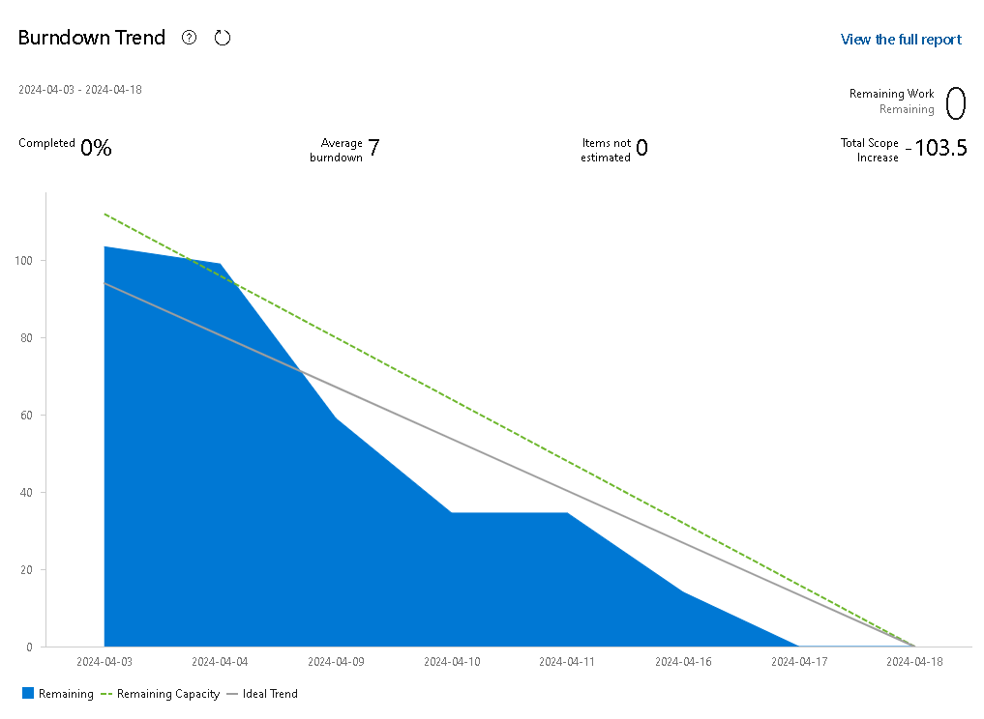

Things were tasked out properly, and the work was done early, but not too early, leaving a bit of extra time for review.

* 1. Find a task that was completed and the history of how it went through it’s different states (2 marks).

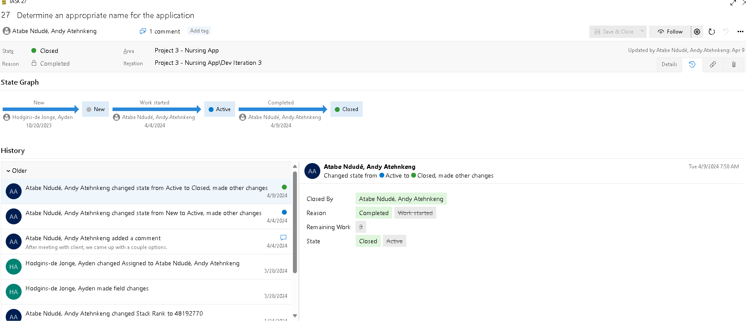

## **Part B – Using Azure Workflow (Team work)**

You will work in **teams** assigned by the professor for this lab. Marks will be given for individual participation.

1. The work for the lab will be done in Azure DevOps. Log in to the Azure DevOps project for your team using the link shown below. You must show me your finished product for the lab in Azure DevOps.
2. When your team is ready to have your lab marked, notify the professor.

|  |  |  |
| --- | --- | --- |
| Student first name | Lab3Teams | Project Location |
| Pierre | 1 | <https://csazure.cegep-heritage.qc.ca:8080/K30SystemsMaintenance/K30_F24_Lab3_Group1> |
| Gautam | 1 |  |
| Sebastian | 1 |  |
| Matteo | 1 |  |
| Jade | 2 | <https://csazure.cegep-heritage.qc.ca:8080/K30SystemsMaintenance/K30_F24_Lab3_Group2> |
| Julia Maria | 2 |  |
| Pax Bertin | 2 |  |
| Joshua | 2 |  |
| Heraj | 3 | <https://csazure.cegep-heritage.qc.ca:8080/K30SystemsMaintenance/K30_F24_Lab3_Group3> |
| Jacob | 3 |  |
| Benjamin | 3 |  |
| Brandon | 3 |  |
| Cristian | 4 | <https://csazure.cegep-heritage.qc.ca:8080/K30SystemsMaintenance/K30_F24_Lab3_Group4> |
| Ryan | 4 |  |
| Parker | 4 |  |
| Carlos Branimir | 5 | <https://csazure.cegep-heritage.qc.ca:8080/K30SystemsMaintenance/K30_F24_Lab3_Group5> |
| Sabrina | 5 |  |
| Claude | 5 |  |

Assemble into your teams. Make sure you start by reading the entire lab document to understand the scope of the work you must complete as a team to ensure you are able to complete it and have it marked by the end of the lab.

Collateral you will build in Azure DevOps for this lab includes:

1. Product backlog containing user stories;
2. Sprint backlog containing user stories and tasks;
3. User Story has:
   1. Priority (from Product Owner) – implicit from where it is in the Backlog stack, i.e., higher priority items are at the top of the stack; and
   2. Acceptance Criteria.
4. Tasks are sized in hours and relate back to a single user story;
5. A Scrum/Kanban board showing your sprint backlog/status; and
6. A burn down chart.

### **Part 1 – Creating a User Story**

**Situation:**

Lisa works for Heritage College administration.

Lisa wants an online system so that professors and students can buy parking passes online.

Parking passes are $120 and are good for one semester. Parking can be paid for in cash, credit card, or payroll deduction (for professors only).

**To do:**

Using the structure: As a (role) I want (something) so that (benefit), define a single user story, that Lisa would write to describe the above. Record this original user story in your Azure DevOps project.

### **Part 2 – Detailing a User Story**

**Situation:**

Lisa wants many other features, but has prioritized the parking pass feature at the top of the Product Backlog. Lisa has asked for an estimate on how long it would take. At a glance, this user story is an epic and cannot be done in a single sprint. It has to be split up.

**To do:**

Split the original story using one of the splitting strategies discussed in Week 1. Provide **3** smaller user stories in Azure DevOps. Make sure you link the smaller ones to the original one.

During marking, be prepared to discuss what strategy you used for splitting the original story and why.

### **Part 3 – Acceptance Criteria**

**To do:**

For each of the 3 smaller user stories, provide acceptance criteria. Group the acceptance criteria as functional vs. non-functional. Make sure you include sufficient criteria to have the “definition of done” – i.e., how you will show/agree that you have fully implemented the stories correctly.

### **Part 4 – Sprint planning, Breaking the User Story into Tasks, Estimation**

**To do:**

1. Consult with your Product Owner (Lisa, but in this case your professor will take on this role on her behalf) to get her to prioritize your user stories.
2. Now that the user stories are smaller and detailed, your agile team sizes each user story. Think of your design as you do this and ensure that your solution is scalable, i.e. make sure you will be able to build on it and implement more features in future sprints. Break each user story into tasks. Size the tasks in hours. Make sure you enter your estimates as remaining work. During marking, be ready to discuss how you came up with these hours (for instance, did you use one of the estimation techniques we talked about in Week 1?) Total the tasks to determine the estimate for each user story.
3. Assume each sprint has about 120 hours of capacity. Determine the contents of your first sprint and what the demonstratable sprint goal will be. Establish the sprint backlog in the first sprint / iteration in your Azure DevOps project.
4. When this is complete, show me your sprint content and board in Azure DevOps.

**To submit:**

* There is nothing to submit in Moodle for this lab. However, you must ensure that all your lab material is available for review in Azure DevOps at the end of the lab.

**Marking Scheme**

|  |  |
| --- | --- |
|  | Marks |
| **Part A - analysis** |  |
| Overview | 4 |
| Product backlog | 2 |
| Sprint backlog | 2 |
| Taskboard for Sprint | 2 |
| Burndown chart for Sprint, analysis | 4 |
| Task details | 2 |
|  |  |
| **Part B - teams** |  |
| Part 1 Original User Story | 2 |
| Part 2 3 smaller user stories | 6 |
| Part 3 Acceptance Criteria | 6 |
| Part 4 |  |
| Product Backlog, Prioritized | 3 |
| Task breakdown | 15 |
| Estimates | 10 |
| Sprint backlog | 15 |
| Board | 5 |
| Burndown Chart | 2 |
| Individual mark for participation and answering questions. | 8 |
|  |  |
| Total | 88 |